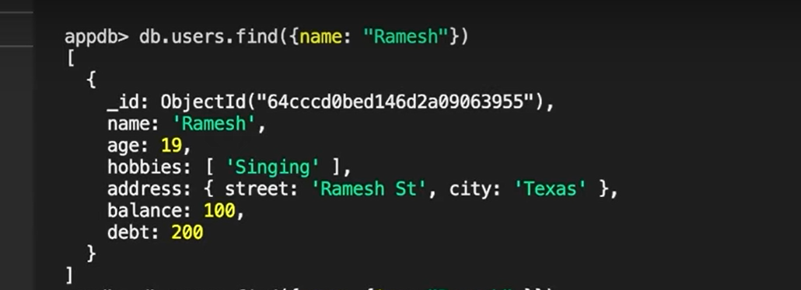

* To find data Normaly

**Complex Qurey:**

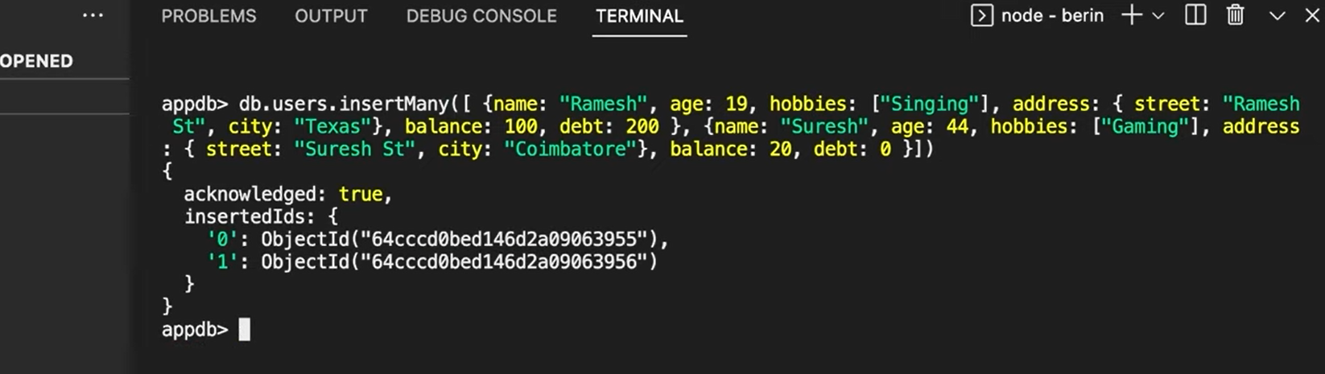

* **To insert many data**

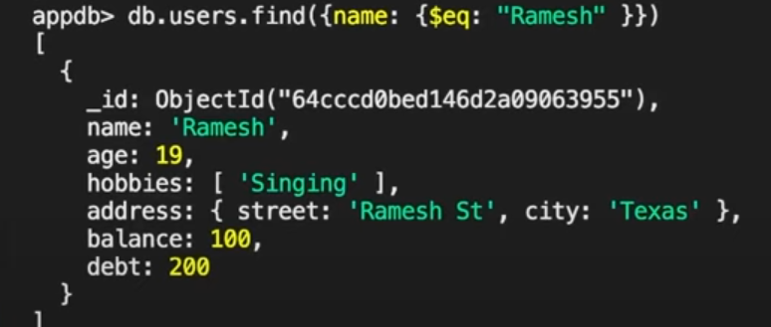

* **To find data in complex**
* **Eq🡺 equal to**

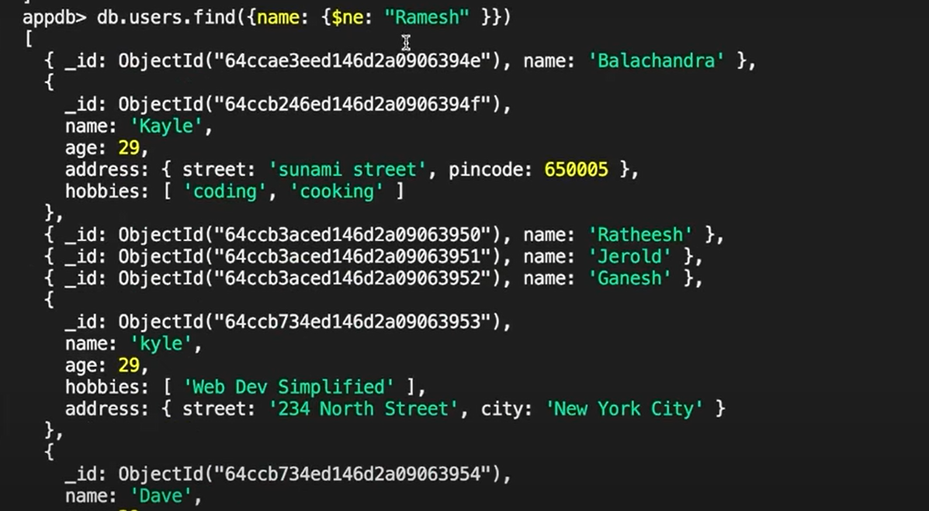

* **Ne 🡺 Not Equal to**

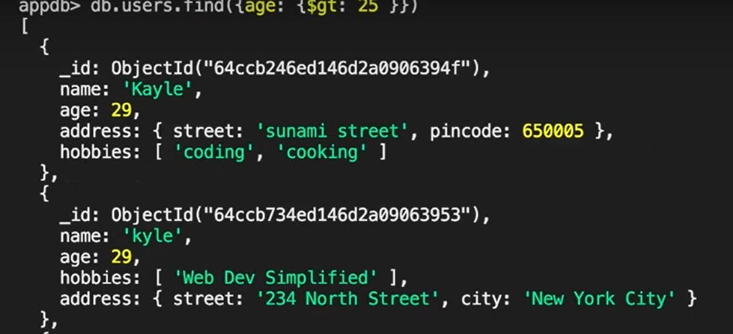

**Gt🡺grater than**

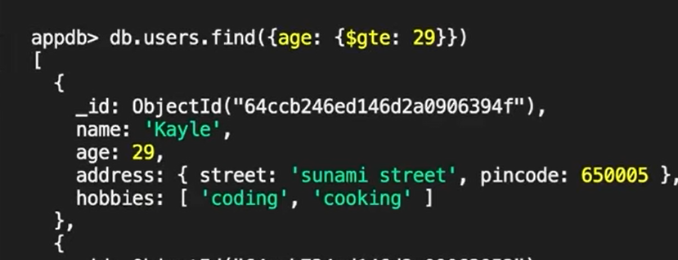

* **Gte 🡺 graterthan equlato**

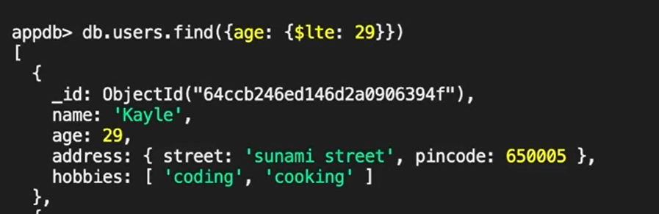

**Lte🡺lesserthan equal to**

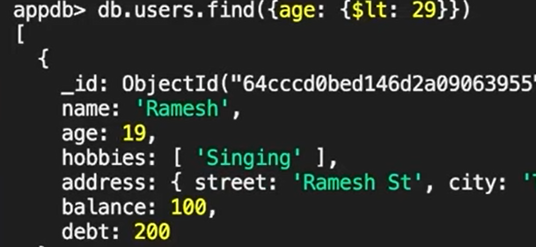 **Lt🡺 lesserthan**

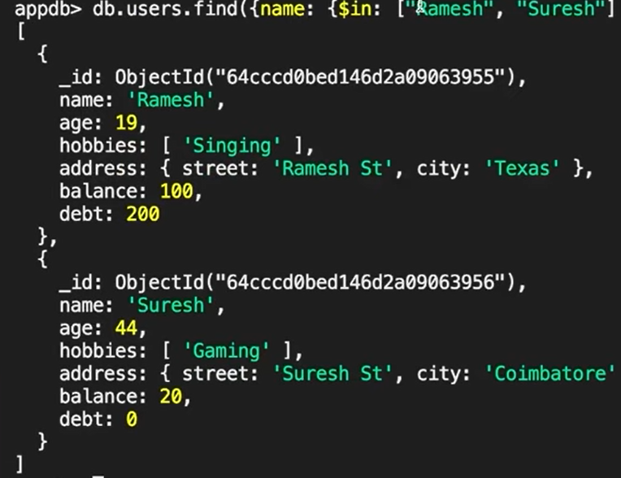

* **in 🡺**

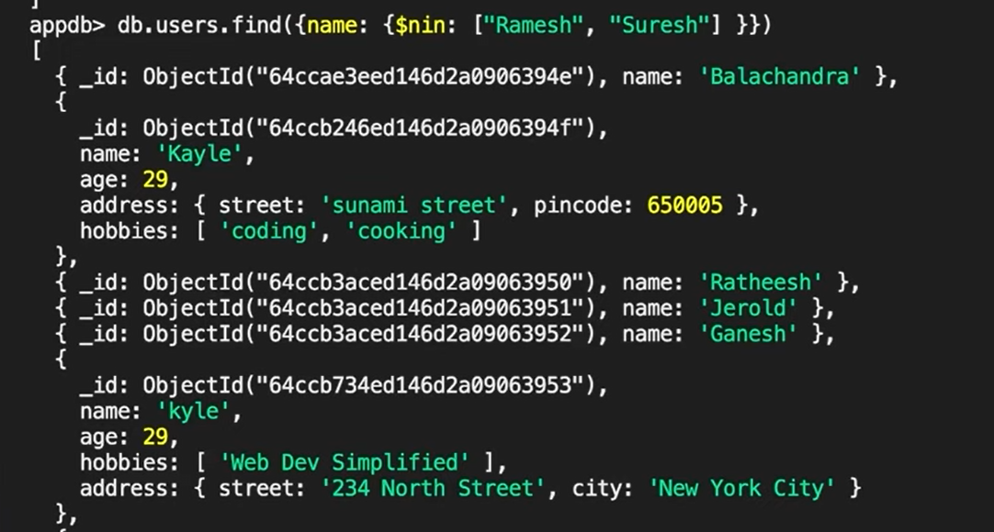

* **nin 🡺not in**

**AND:**

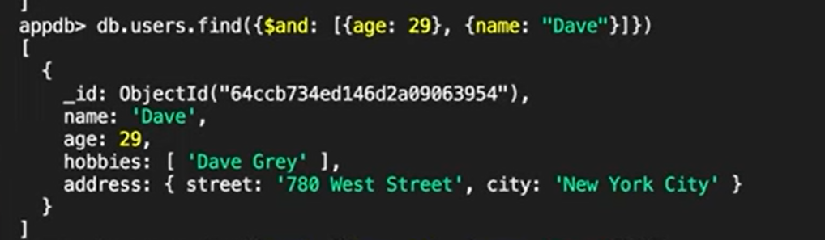

**OR:**

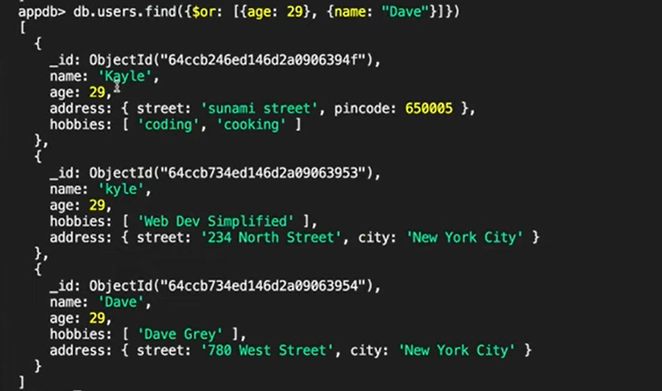

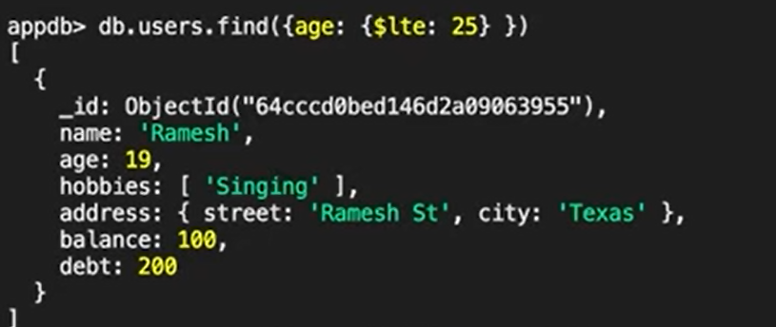

**NOT :**

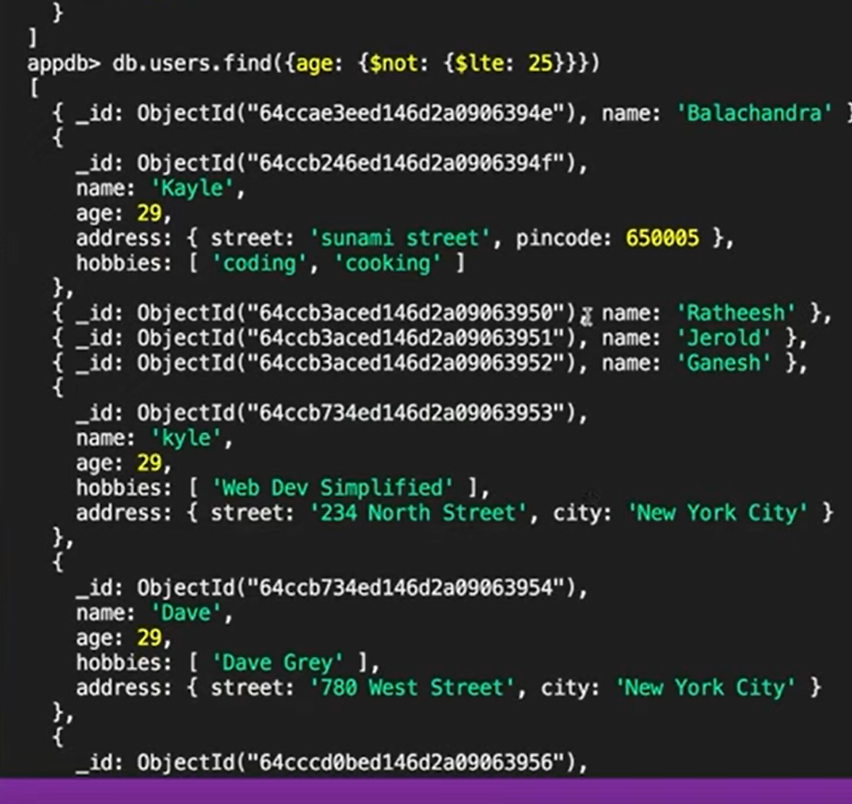

**Dept:** 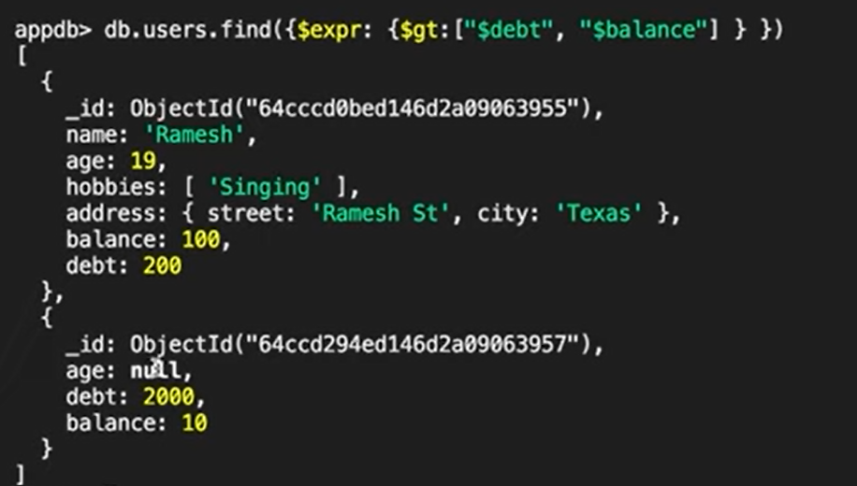

**Address:**

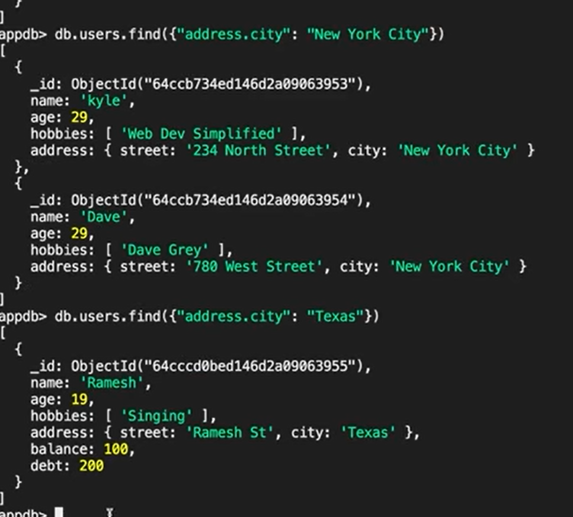

**FindOne:**

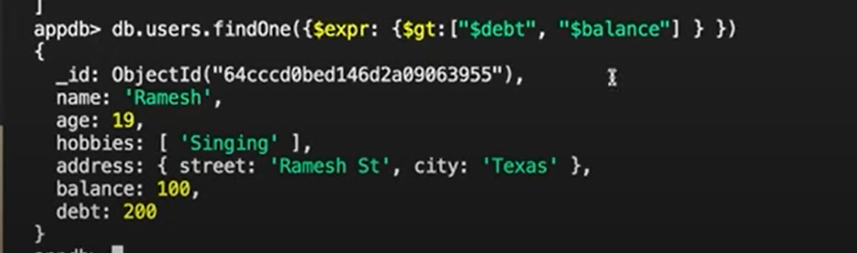

**CheckOut:**

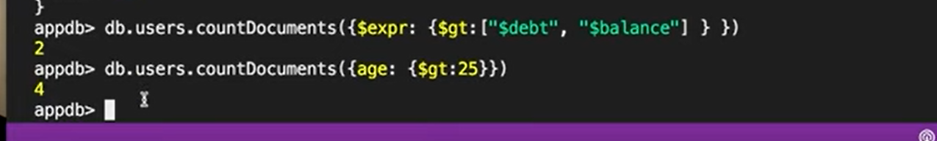

**UPDATE:**

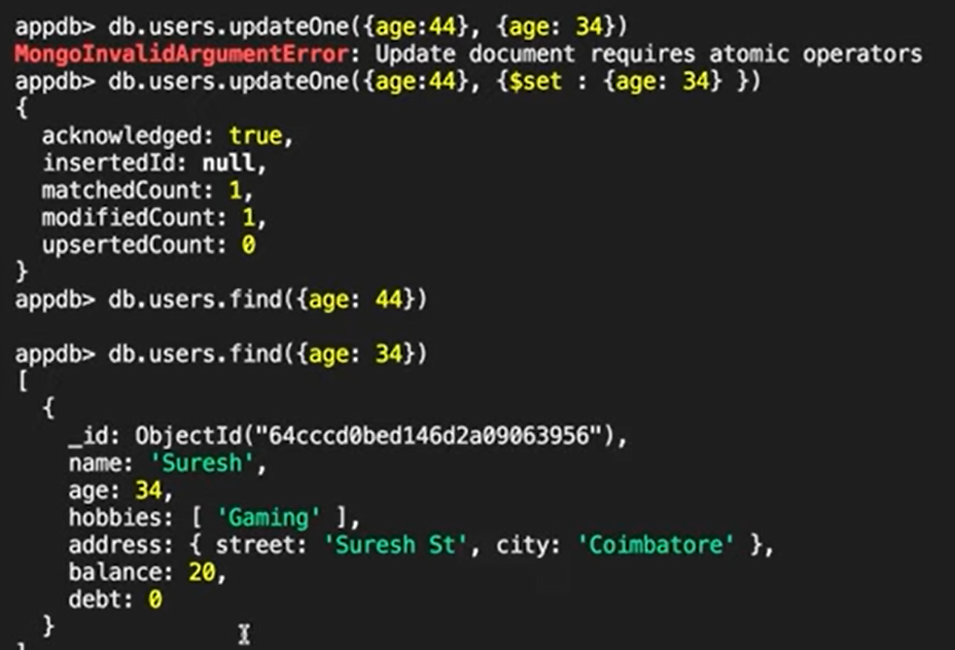

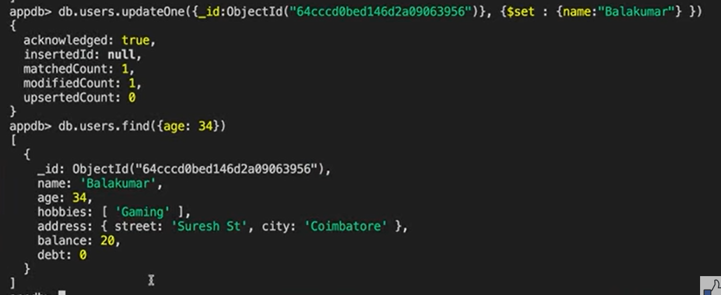

**INCREMENT:**

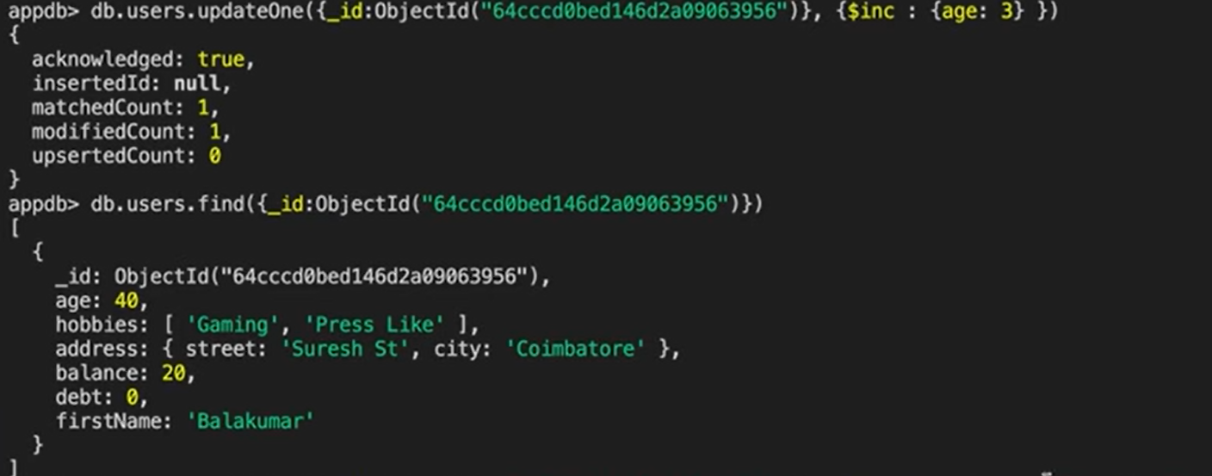

**RENAME:**

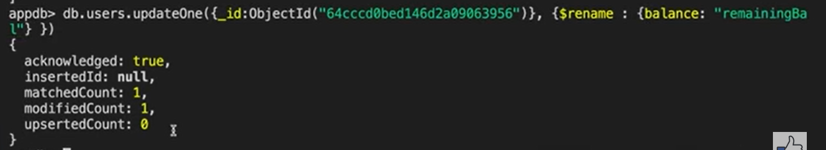

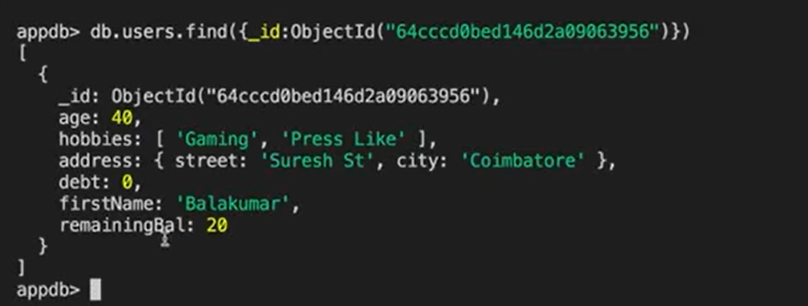

**PUSH:**

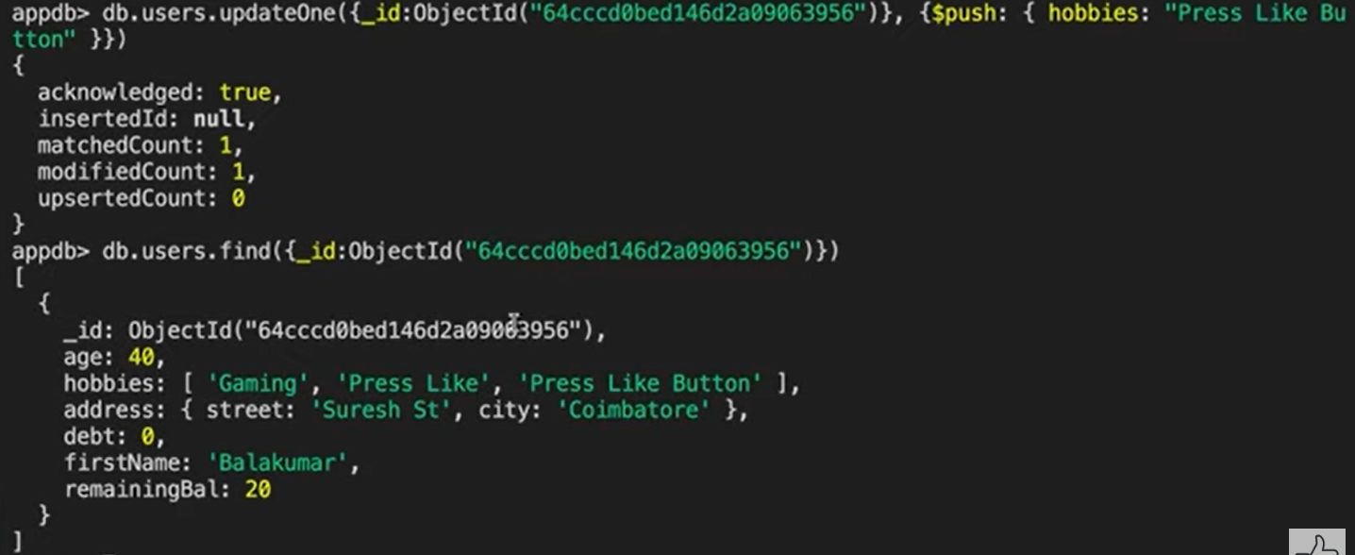

**PULL:**

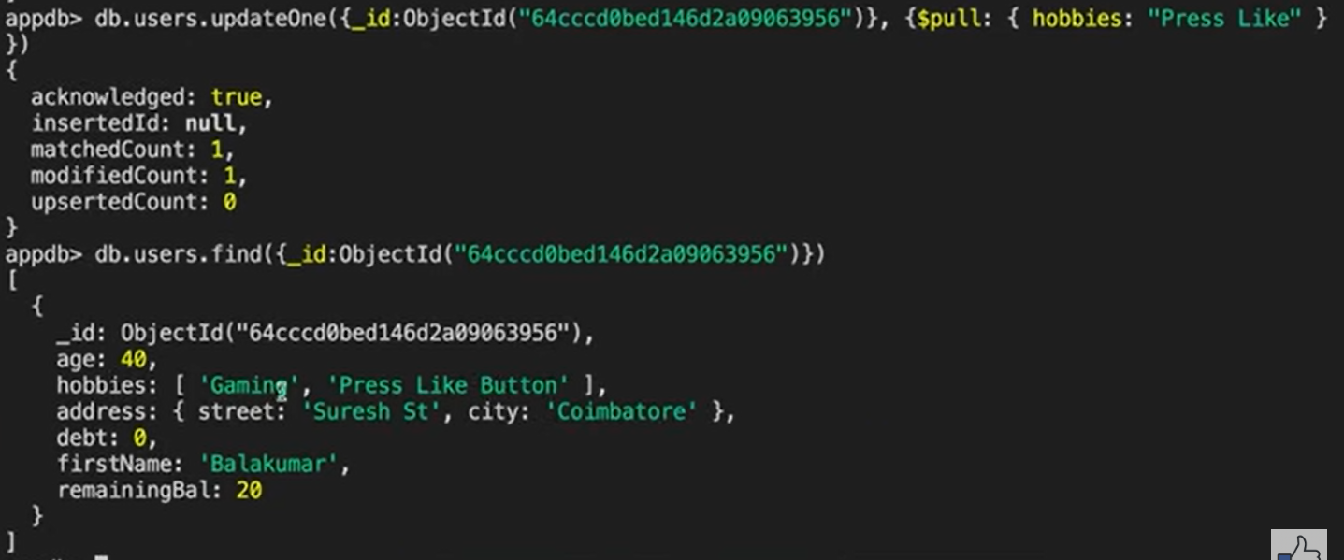

**UNSET:**

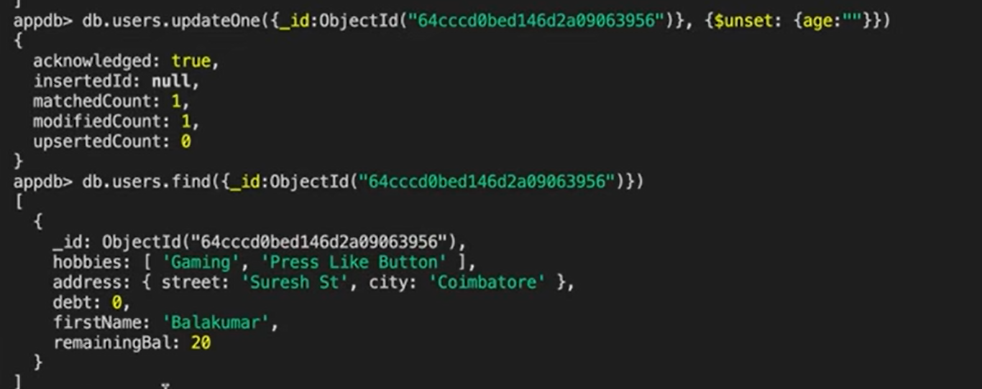

**For many function at a time:**

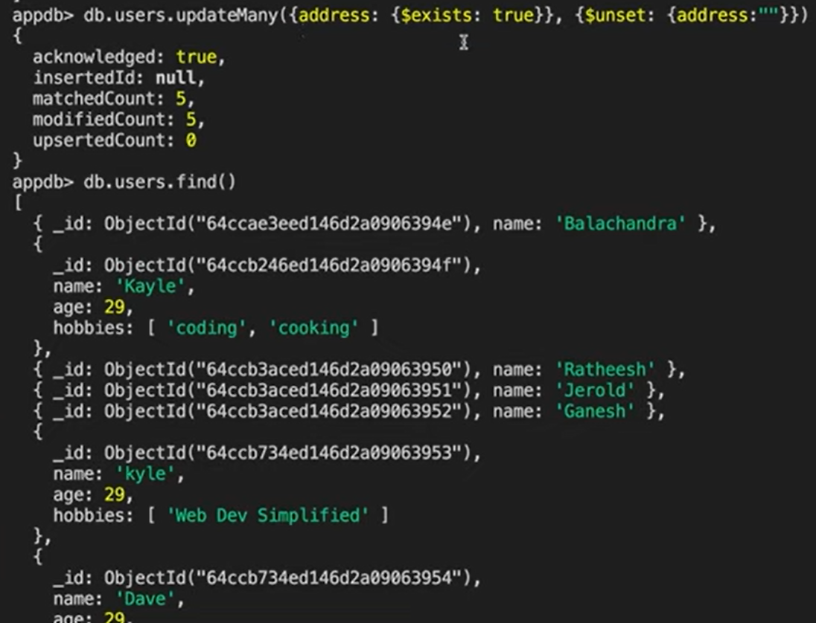

**Remove the address in many data.**

**REPLACEONE:**



**Replace whole content with one function:**

Before:

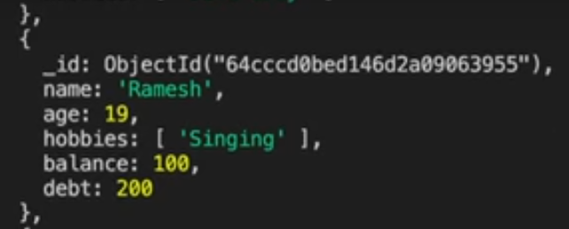

**After:**

